Word Processing

Motivation:

Encountering a no. of posts such as this makes me wonder How does the human mind work to read words?

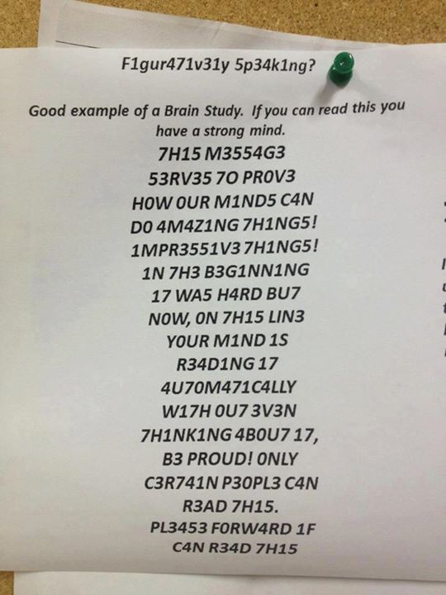

Encountering a no. of posts such as one above makes me wonder. How does the human mind work to read words? What is the process of understanding these words?

In the above picture the words have been replaced by nearest numbers in 0-9. With T=7, S= 5, I = 1 ,E=3, O=0, which confirms one thing for sure that the human mind does not look for the letters as such but recognises letters with strokes (say horizontal and vertical) as in Bouma Theory.

Another such post is:

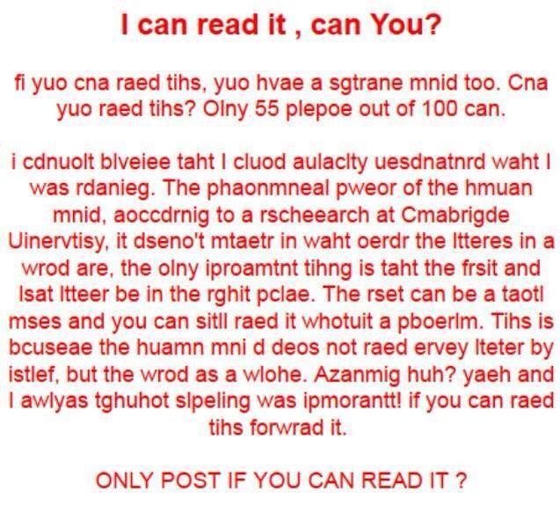

One can notice that after you have started reading the paragraph you don’t have much trouble. The paragraph says that the actual order of letters is not important for human mind to perceive the word. Which is quite surprising?

A similar image: which makes us wonder visual inputs are processed.

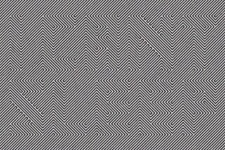

## Lexical Access and Word Recognition

The process by which we obtain information about the meaning and syntactic properties of a word from our mental lexicon.

"the ability of a reader to recognize written words correctly and virtually effortlessly."

# Theories of word recognition

Bouma shape Theory:

Suggest that people recognize words from the shape the letters make in a group relative to each other. The proof of the theory is the first example. The slower pace with which people read words written entirely in upper-case, or with alternating upper- and lower-case letters, supports the bouma theory. Studies have also concluded that mis-spelled words with identical shape are less likely to be noticed than misspelled words with different shape. This is another proof to the theory.

Parallel recognition vs. serial recognition:

According to this, all letters within a group are perceived simultaneously for word recognition. The theory has been rejected as it cannot explain word superiority.

Neural networks of word recognition:

According to theory: “The visual aspects of a word, such as horizontal and vertical lines or curves, are thought to activate word-recognizing receptors. From those receptors, neural signals are sent to either excite or inhibit connections to other words in a person’s memory. The words with characters that match the visual representation of the observed word receive excitatory signals. As the mind further processes the appearance of the word, inhibitory signals simultaneously reduce activation to words in one’s memory with a dissimilar appearance.” As stated in Wikipedia.

References:

Wikipedia: <https://en.wikipedia.org/wiki/Word_recognition?oldformat=true>